Cultivated Italy: Gardens, History & Vineyards
Over 14 days, we'll explore Italy from Rome to Venice, visiting an extraordinary range of gardens, villas, and cultural landmarks. The tour includes 6 lunches and 5 dinners, private coach transportation, expert guides, and all admissions to over twenty remarkable sites.

We'll be staying exclusively in 4- and 5-star hotels, with upgraded rooms where possible - including superior rooms in Sestri Levante for extra comfort. I've chosen these accommodations carefully to ensure that every evening feels like part of the experience, not just a stop along the way. I believe the quality and inclusions make this a truly exceptional value.

October 2 – 15, 2026
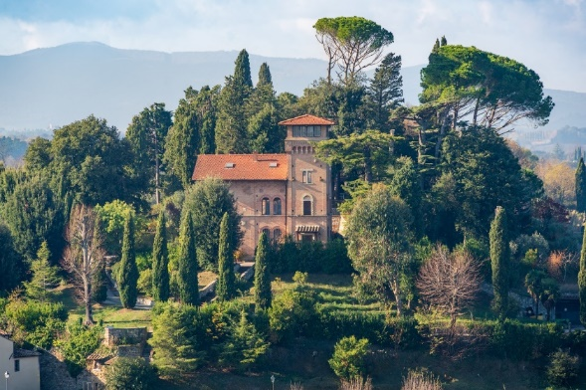

Tour at A Glance Italy
Price- US $8,480.00 (USD) per person, double occupancy
Single Supplement $2,675.00 (USD) per person, single occupancy, additional

Cost Includes

- 13 nights luxury hotel accommodation (4/5 star)
- Breakfast daily
- 6 x 2-course lunches, 5 x 3-course dinners
- Transfer by Vaporetto in Venice
- Truffle hunting in Mugello with lunch
- 1 hour private canal boat guided tour of Venice
- Evening concert of Vivaldi’s music in Venice
- Glasswork studio visit in Venice
- Entrances to Farnese Gardens in Rome, Villa D’Este, Villa Adriana, Garden of Ninfa, Deruta Ceramics, Siena Cathedral and Library, Piazza del Campo, Boboli Gardens and Pitti Palace,Villa Lante, Sacro Bosco, Villa Reale di Marlia e parco, Abbazia della Cervara, Giardinia Botaniico dii Villa Taranto, Palazzo Borromeo Isola Bella, Isola madre, Villa Carlotta, Villa de Balbaianello
- Wine tasting with appetizers at Tuscany
- Truffle Hunting in Mugello
- Pisa field of Miracles
- Florence and Venice guided tours
- Ferries to islands in Italian Lakes
- Services of local Italian tour manager throughout
- Whisper headsets included throughout
Not Included
- International Air fare
For full itinerary, go to: https://tri.ps/ECQFH
For more information, email Claire Jones jonesb1@comcast.net

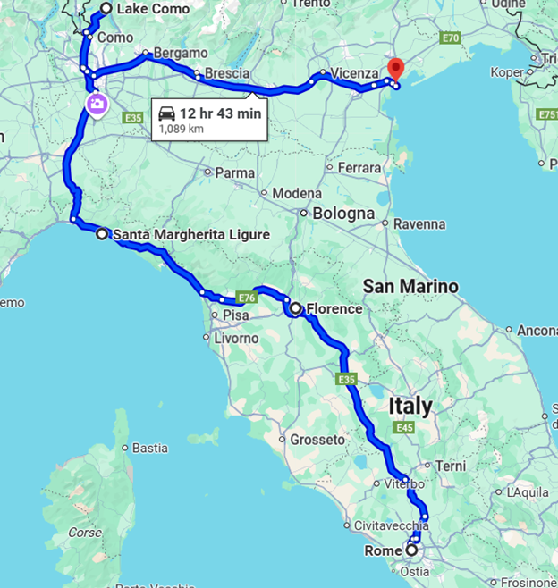
Join me for an unforgettable 14-day journey from Rome to Venice, exploring Italy’s most exquisite gardens, historic villas, and cultural treasures. Enjoy private coach transportation, expert guides, and admissions to more than twenty remarkable sites.
Your experience includes 6 lunches and 5 dinners, along with 4- and 5-star hotels throughout—featuring upgraded rooms whenever possible, including superior rooms in Sestri Levante for added comfort.
Every detail has been thoughtfully chosen to ensure this tour offers not just exceptional beauty, but exceptional value.

